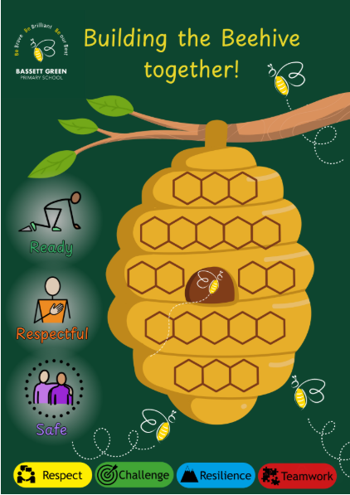
Beehive System and Recognition Flowchart

Our Recognition Philosophy
At Bassett Green Primary School, we believe behaviour should be recognised and reinforced positively. Recognition
motivates pupils to ‘Be brave, Be brilliant, Be our Best’ contributing to a happy, mutually respectful school community. The
Beehive System celebrates effort, kindness, teamwork, and emotional growth, linking every success to our rules and values:

Ready – Respectful – Safe Challenge – Resilience – Respect – Teamwork

The Beehive System: Recognition Flowchart
Step | Focus | Recognition Method | Mechanism & Criteria | Reward/Outcome
1. Little and Often Wins | Individual recognition | Stickers, verbal praise. | Staff use Positive Noticing to reinforce Ready, Respectful, Safe behaviours and school values (CoEL in EYFS). When 5+ pupils are recognised for the same value, the class earns 1 hexagon on the class Beehive. | Builds confidence and self-esteem; visible progress toward class goals.
2. Skills Bucket | Whole-class skill development | Pom-poms in class bucket | Linked to a weekly target written on the Above and Beyond Board (e.g. teamwork, resilience, listening). Pom-poms added when pupils practise the skill and name added to the Recognition Board (aim is for all pupils to be on the board by the end of the day). When the bucket is full, the class earns 1 hexagon. | Reinforces shared responsibility and collaboration.
3. Stars in a Jar | Collective routines & consistency | Stars awarded for collective success | Staff add stars when the class demonstrates collective success (lining up, transitions, kindness). When 20 stars are earned, the class earns 1 hexagon. | Encourages consistent routines and pride in teamwork.
4. Values (CoEL in EYFS) Reflection & Hive Celebration | Weekly reflection and celebration | Peer nominations, staff praise, assembly recognition | Each week, pupils reflect on the Recognition Board and/or which rule or value they have embodied most. Peers nominate the classmate they believe has most consistently demonstrated going above and beyond in the week (KS2) and the teaching team complete a ‘Positive Postcard home’ for that child. This is celebrated in assembly and the pupil sits on the hive table at lunchtime the next week.  When a class completes their Beehive (20 hexagons), they are celebrated in assembly and choose an agreed reward from the class Menu of Motivation. | Builds community, strengthens prosocial behaviour, celebrates effort and inclusion.

Menu of Motivation: When a class completes their Beehive, they select one non-material, inclusive reward to celebrate success and teamwork.

How the Beehive System Works
- Daily: Staff give individual recognition and add collective stars/pom-poms.
- Weekly: Classes reflect on values and celebrate effort.
- Weekly: Completed Beehives are recognised in assembly with a chosen reward.
Impact: Fosters intrinsic motivation, emotional literacy, and a strong sense of belonging.

