
10-for-10


Holiday Challenge: Mathematics ‘10 Challenges for 10 Days’

This booklet is designed to keep your brains ‘ticking over’ during the termly break. Just a few short activities will mean that you return ready to learn and raring to go!
Try to really impress your teacher by completing the challenges for each of the 10 days.
Circle any questions that you’d like some more help with when term starts again.

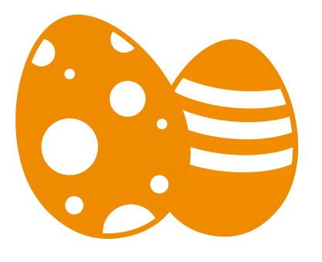© Commissioned by The PiXL Club Ltd. FEBRUARY 2019

Easter

Revision
This resource is strictly for the use of The PiXL Club Ltd member schools during the life of the membership only. It may NOT be copied, sold, or transferred or made available by whatever means to a third party non-member during or after membership. Until such time it may be freely used within the PiXL member school by their teachers and authorized staff and any other use or sale thereof is strictly prohibited.

All opinions and contributions are those of the authors. The contents of this resource are not connected with, or endorsed by, any other company, organisation or institution.

PiXL Club Ltd endeavour to trace and contact copyright owners. If there are any inadvertent omissions or errors in the acknowledgements or usage, this is unintended and PiXL will remedy these on written notification.


Day 1

Arithmetic Questions

1

3

4

1 mark
456 x 8 =

5.6 x 10 =

360 ÷ 6 =

1 mark

1 mark

8 - 20 =

102 + 4,000 =

2
5

1 mark 1 mark

6
Complete the missing numbers in the sequence.

8, 4, 0, , , -12
Day 1

Reasoning Questions

9

1 mark
Calculate the missing angle ‘A’.
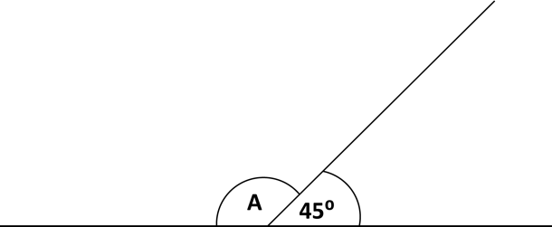
7
Circle the number which is closest in value to 5.

5.3 5.03 5.1 5.13 5.33

8
Write in the missing numbers to complete the grid.

x
8 | 32 | 24
 | 28 | 21

1 mark

1 mark

10
The price of a highlighter pen is 75p when bought individually.
A pack of 5 highlighter pens is £3.50. How much cheaper is one pen
when bought as part of a pack? Show your working.

1 mark

1 mark

Day 2

Arithmetic Questions

1

3

4

1 mark
0.67 x = 67

5,060 - 239 =

3,672 ÷ 8 =

1 mark

1 mark

24 x 25 =

= 305,324 + 3,000

2
5

1 mark 1 mark

6
The diagram below is made of squares and triangles. What fraction of the diagram is shaded?

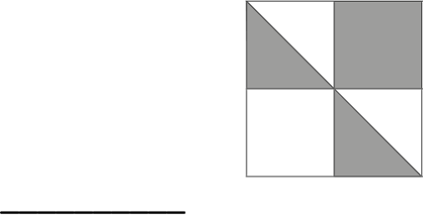

1 mark
Day 2

Reasoning Questions

7

Kim says, ’20,001 cannot be a multiple of 4’. Explain why she is correct.

9
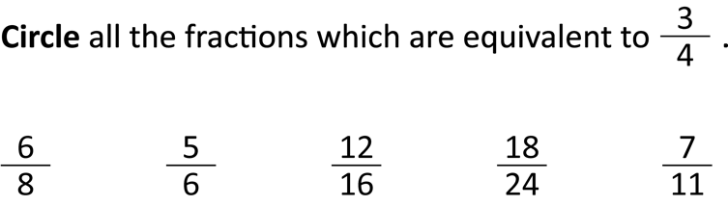

8

1 mark

1 mark
10

Jack ran the 100m in 15.4 seconds. Sima ran it two seconds faster. What time did Sima record for her run?
Write these numbers in ascending order.

0.4 0.48 0.39 0.048 0.41

1 mark 1 mark

Day 3

Arithmetic Questions

1
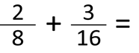
3

4

1 mark
34.5 + 124.8 =

6 - 3.25 =

52 + 355 =

1 mark

1 mark

= 456 ÷ 100

2
5

1 mark 1 mark

6
The value of the number in each circle is the same. What is the value of a circle?

+ + = 270
Day 3

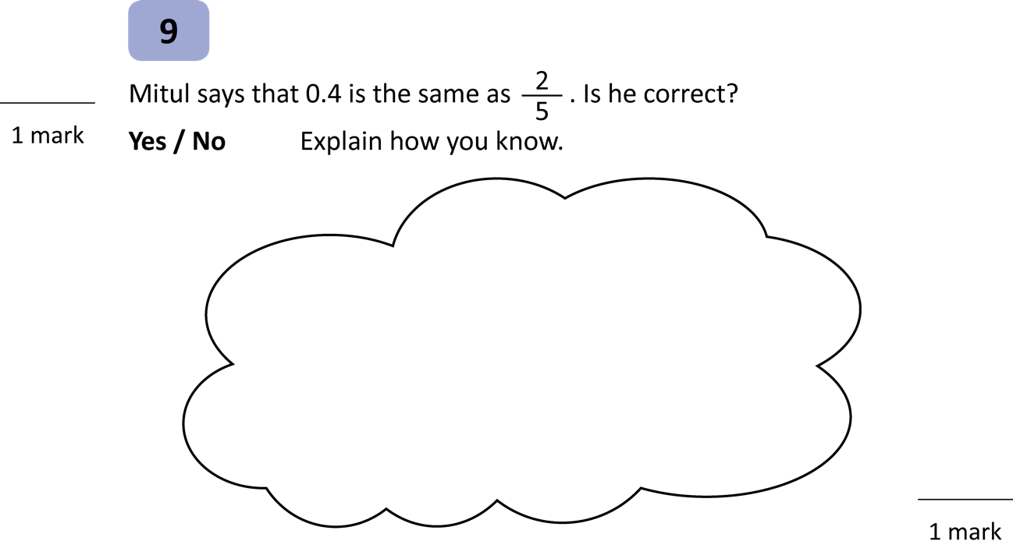
Reasoning Questions

7
Complete the table below.
 | Rounded to the nearest 10 | Rounded to the nearest 100
85.6
123.45
399.98

1 mark
10

8
Write a number in the box to make the statement true. ( ÷ 7) - 8 = -1

1 mark
For their Y6 picnic, Class 6H have worked out that they need 24 loaves of bread to make sandwiches. If each loaf is 95p, what is the cost of the bread altogether? Show your working.

1 mark

Day 4

Arithmetic Questions

1

3

4

1 mark
75 - 10 = 52 +

-12 + 20 =

1 mark

1 mark

0.09 x 1,000 =

568.4 - 25.3 =

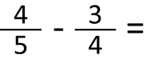
2
5

1 mark 1 mark

6
Write the following numbers in the correct place on this Venn diagram.
240 44 35 42 400
Multiples of 3 Multiples of 4
Day 4

Reasoning Questions

1 mark
7

Mr. Smith bought a bag of 5 apples which weighed 585g in total. The bag weighed 5g. What is the weight of one apple? Give your answer in kg.

kg

1 mark

Label (or colour) the diagram below so that the ratio of red (R) to green (G) is 5:2. Two have been completed for you.
9

R | G

1 mark

10

The rectangle below has a perimeter of 50cm. Find the missing distance labelled ‘B’.
8
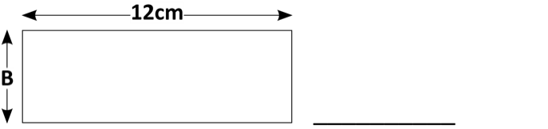
I think of a number. I halve it and add 2. I then multiply it by 3. My answer is 48. What is my number?

1 mark 1 mark

Day 5

Arithmetic Questions

1

3

4

1 mark
2,340 ÷ 1 =

= 3,500 + 600

1 mark

1 mark

20% x 300 =

84,540 ÷ 15 =

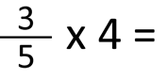
2
5

1 mark 1 mark

6
Calculate the area of this right-angled triangle.
Day 5

Reasoning Questions

7cm

5cm
7
Here are some digits.

2 4 5 6 7 9
Use all the digits once to create a square number, a prime number and a multiple of 7.

Square Number Prime Number Multiple of 7

1 mark

9
There are 600 pages in a book. Jake has read 40% of them.
How many more pages has he got left to read? Show your working.

8
Here is a number sentence. 8 x < 65

Circle all the numbers which could fit into the number sentence to make it true.

6 15 9 7 5.5

1 mark

1 mark

10
500 people attend a concert. There are 7 children to every 3 adults. How many children are at the concert? Show your working.

1 mark

1 mark

Day 6

Arithmetic Questions

1

3

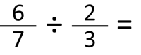
4

1 mark

65 - 49 ÷ 7 =

400 x 60 =

1 mark

1 mark

0.08 x 100 =

254 x 9 =

2
5

1 mark 1 mark

6
The pie chart below shows the favourite events at the Winter Olympics. Use the information to estimate the percentage of people who liked snowboarding the most.

Favourite events at the Winter Olympics

Snow Boarding

Ski Jump

Downhill Skiing
Half Pipe

1 mark
Day 6

Reasoning Questions

9
A floor is covered in tiles in the shape of identical parallelograms. Calculate the area of one parallelogram from the information below. Show your working.
100cm
12cm

7

Circle the number that is 100 times greater than 5.6

0.56 56 5,600 560 5,006

1 mark

1 mark

10

Estimate the number shown by the arrow. 50,000
8

100,000
In the ski jumping event in the Winter Olympics, five athletes jumped the following distances. Calculate the mean of their distances.

m
147.2 m 145m 0.14km 137.8m 145m
1 mark

1 mark

Day 7

Arithmetic Questions

1

3

4

1 mark
26 - 36 =

3,456 x 1,000 =

250 + (9 x 5) =

1 mark

1 mark

123.9 + 0.34 =

= 9,865 - 100

2
5

1 mark 1 mark

6
A shop has a 20% discount sale. A pair of trainers are usually £36. How much would they be in the sale? Show your working.

1 mark
Day 7

Reasoning Questions

7
9

The diagonals of two shapes are drawn below.
Write down the name of each shape in the space next to it.
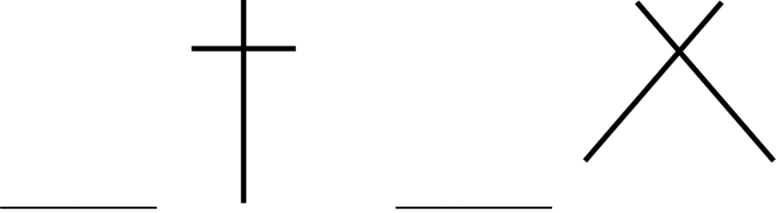
Circle all the numbers that are multiples of 9.

118 18 89 540 81

1 mark
8
A roll of sandwich bags is 450cm long. Each bag is 15cm long. How many bags are there in a roll? Show your working.

1 mark

10
Draw a line from the shaded box to the correct pair of numbers which make this statement true.

3t + y = 5
t = 1, y = 4
t = 1, y = 2
t = 2, y = 3
1 mark

1 mark

Day 8

Arithmetic Questions

1

3

4

1 mark
15 x 4.2 =

50 x 25 =

4,655 ÷ 19 =

1 mark

1 mark

3,456 + 999 =

= 92 + 32

2
5

1 mark 1 mark

6
There were 112 roller skaters on a rink. 60 dropped out but a further 26 joined. How many roller skaters are there now? Show your working.
Day 8

Reasoning Questions

8

7
Complete the sequence of numbers.

1 mark
Two of the vertices of an isosceles triangle have these coordinates:
(1, 3) (3, 3). Plot the points then plot a third vertex to complete the shape.

Write down the coordinates of your third vertex.
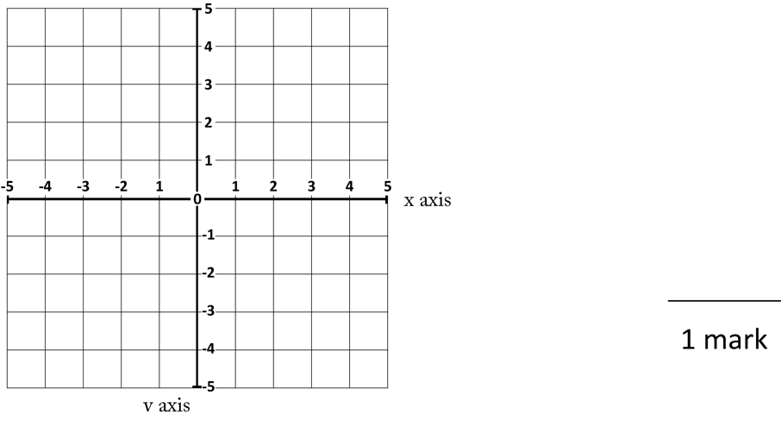

9 16 25 36
1 mark

Leroy says that 146 will be in the sequence. Is he correct?
Yes / No Explain how you know.

Circle all the numbers that are common multiples of 4 and 6.
9
240 30 120 16 48

1 mark

Write one number in each box to make the number sentence true.
10
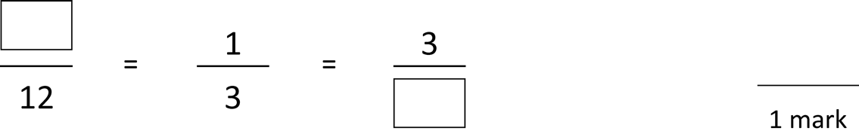

1 mark

Day 9

Arithmetic Questions

1
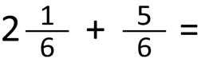
3

4

1 mark
25% of 500 =

25 + (9 x 12) =

4,568 ÷ 4 =

1 mark

1 mark

2,345 x 7 =

2
5

1 mark 1 mark

6
Complete the bus timetable below.
Route | Departure Time | Arrival Time | Duration of Journey
Dibden - Sutton | 09:45 |  | 55 Minutes
Tulling - Fripton | 11:15 | 13:40
Sibsey - Monkton |  | 15:45 | 1hr 15 Minutes

Day 9

Reasoning Questions

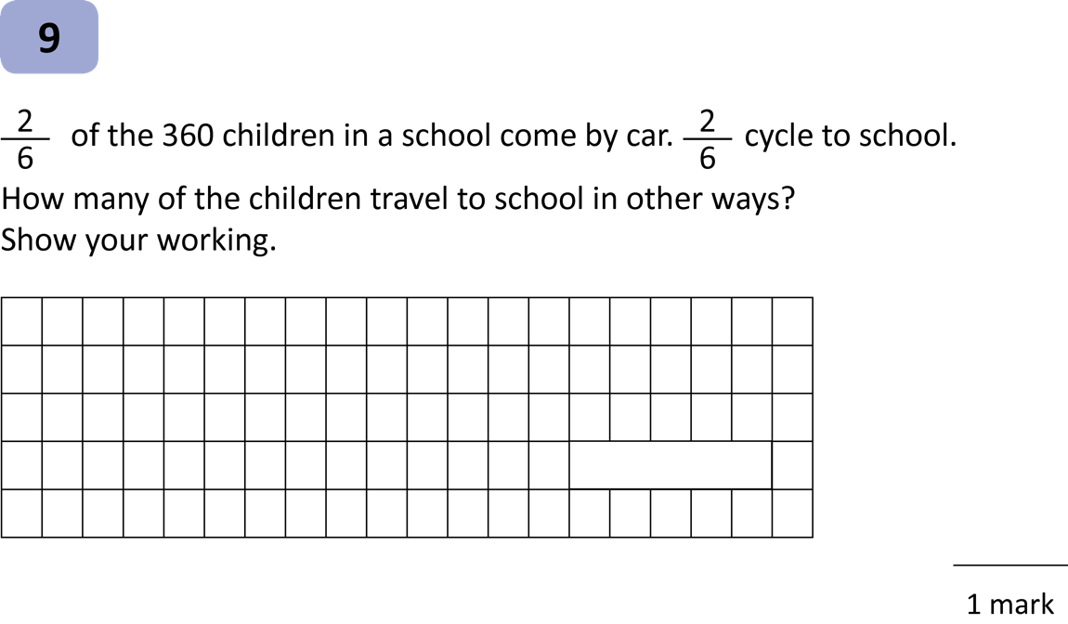

1 mark

A shop has 270 pairs of jeans displayed on shelves. Each shelf holds 18 pairs of jeans. How many shelves are needed? Show your working.
7

1 mark

10

Circle all the common multiples of 5 and 6.
8
30 55 120 90 66
Insert a pair of brackets to make this statement true.
15 + 9 x 8 = 87

1 mark 1 mark

Day 10

Arithmetic Questions

1

3

4

1 mark
0.04 x = 40

1 mark

1 mark

2.098 + 12.6 =

- 100 = 5,346

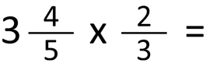
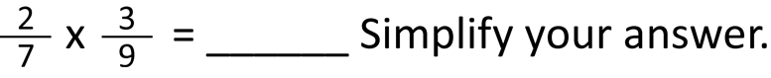
2
5

1 mark 1 mark

6
Tick inside the shapes which have exactly one line of symmetry.
Day 10

Reasoning Questions

9

7
Draw 1 perpendicular line inside this shape to create a trapezium and a triangle.
1 mark
Amina posts four large letters. The postage costs the same for each letter. She pays with a £20 note. Her change is £16.60. What is the cost of posting one letter? Show your working.

1 mark

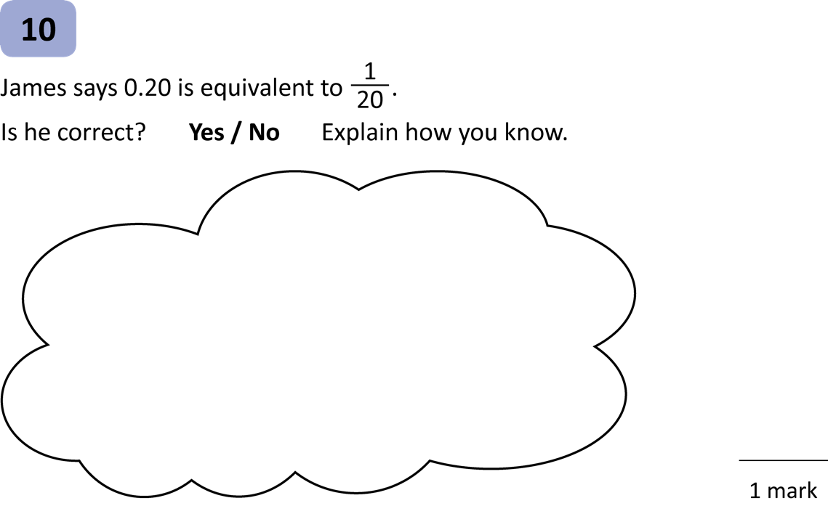
1 mark

8
Insert one of these symbols into each box to make the statements true. < > =
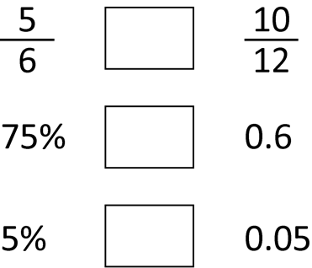

1 mark

