Half Term Holiday Challenge: Mathematics (Set B)
This booklet is designed to keep your brains ‘ticking over’ during the termly break. Just a few short activities will mean that you return ready to learn and raring to go! Try to really impress your teacher by completing one challenge for each day of the week off. Circle any questions that you’d like some more help with when term starts again.

Commissioned by The PiXL Club Ltd.

This resource is strictly for the use of member schools for as long as they remain members of The PiXL Club. It may not be copied, sold nor transferred to a third party or used by the school after membership ceases. Until such time it may be freely used within the member school.
All opinions and contributions are those of the authors. The contents of this resource are not connected with nor endorsed by any other company, organisation or institution.
PiXL Club Ltd endeavour to trace and contact copyright owners. If there are any inadvertent omissions or errors in the acknowledgements or usage, this is unintended and PiXL will remedy these on written notification.

© Copyright The PiXL Club Limited

DAY 1
Arithmetic Questions
1.9 x ________ = 190

3,652 ÷ 8 =
________ - 26,497 = 58,361

$\frac{3}{5}$ of 1,200 =
45.6 x _____ = 4560
45.6 x _____ = 4560
23 + 48 x 3 =
1. Here is a number sentence:
DAY 1
Reasoning Questions
62 - < 48
Circle all the numbers below that make the number sentence correct.
12 48 30 5 13 (1 mark)

2. Here are 6 digit cards.
1 2 3 4 6 7
Use all six digit cards once to make, a prime number, a square number and a number that is a multiple of 4.

Prime number Square number Multiple of 4
(1 mark)

3. Claire thinks of a number. She multiplies it by 10, adds 17 and then halves it. Her answer is 60. What number was she thinking of at the start?
____________(1 mark)

4. Seb says 63 is the lowest common multiple of 7 and 9.
Is Seb correct? Circle Yes or No
Explain how you know.

(1 mark)

5. Write the missing numbers.
_________ 29,364 29,475 ________ 29,697 _________
(1 mark)

$\frac{1}{4}$ + $\frac{3}{5}$ =
=
DAY 2
Arithmetic Questions

9 – 3.62 =
365 x 29 =
$\frac{8}{9}$ ÷ 4 =
560 ÷ ______ = 8
45.6 x _____ = 4560
45.6 x _____ = 4560
1. Look at this bar diagram.
650

Circle all the pairs of numbers that make the whole.
150 + 500 675 – 25 6,050 ÷ 10
580 + 80 6,500 – 100 13 x 50
(1 mark)

2. 3 bags of crisps cost the same as 1 pack of biscuits. Tom paid the shopkeeper £3 for a pack of biscuits and got 39p change.
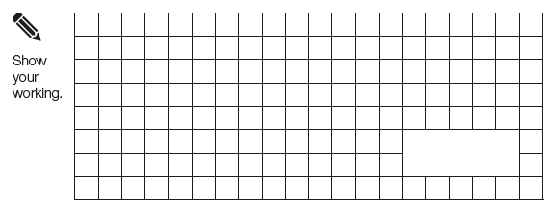
What is the cost in pence of 1 bag of crisps?

(1 mark)

3. This is an addition pyramid. The total in a box is made by adding the two boxes underneath. Use this rule to find the missing numbers.

DAY 2
Reasoning Questions

2,419
1,535

3,098
3,982

(1 mark)

4. Write the missing number
÷ 8 = 9 remainder 5
(1 mark)
5. Tourists to Thorpe Park theme park can get on the largest rollercoaster in groups of 31. If there are 6,762 visitors visiting on one day, how many times does the rollercoaster have to run for all visitors to go on the ride once?

(2 marks)

DAY 3
Arithmetic Questions
92 x 36 =

32.6 + ________ = 41.97
6² =

20% x 360 =
1.9 ÷ ______ = 0.0019
45.6 x _____ = 4560
45.6 x _____ = 4560
- Circle all the fractions equivalent to $\frac{3}{4}$ :
$\frac{3}{12}$ $\frac{15}{20}$ $\frac{6}{9}$ $\frac{30}{40}$ $\frac{12}{20}$
(1 mark)
- Sally is doing a charity cycle. She cycles 3 $\frac{2}{5}$miles in the morning and 2 $\frac{1}{3}$ miles in the afternoon.
How far was her charity cycle?

(1 mark)
3. Write one number in each box to make these fraction sentences correct.

= 1 = 5
12 4
2 + 2 = 6
10 (1 mark)
DAY 3
Reasoning Questions

4. My cats eat $\frac{3}{5}$ of a tin of cat food a day. How many tins will I need to buy to last them one week?

(1 mark)

5. Tim uses $\frac{5}{6}$ of this chocolate bar. Shade the number of chocolate squares he has used.

(1 mark)
16 x 4 + (19 – 8) =
DAY 4
Arithmetic Questions

5³ – 3² =
________ = $\frac{3}{4}$ x 200
______ - $\frac{2}{6}$ = $\frac{1}{3}$
5,692 ÷ 13 =
45.6 x _____ = 4560
45.6 x _____ = 4560
1. Find the value of the symbols.
DAY 4
Reasoning Questions
+ + = 18
- = 2
X = 30

= ________ = ________ = _______ (1 mark)
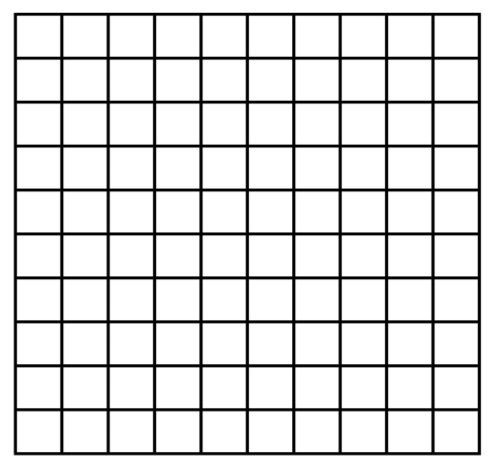
2. Reflect the shape in the mirror line.

(1 mark)

3. 3y + x = 24
When x = 3 y =
When y = 4 x =
(1 mark)

4. Translate the shape 3 squares left and 4 squares up.

(1 mark)
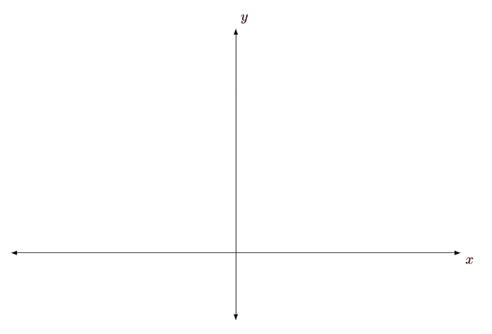
5. Here is a line on a coordinate grid.
C
B
A
O

Points O, A, B and C are equally spaced. The coordinates of A are (12,15).
What are the coordinates of point C?
___________(1 mark)
263,592 + ________ = 274,592
DAY 5
Arithmetic Questions

$\frac{5}{9}$ x 8 =
________ = 6 x 3 x 7
1. Complete this table by rounding the numbers to the nearest whole number.
2.36 x 5 =
35% of 4,000 =
45.6 x _____ = 4560
45.6 x _____ = 4560
Number | Rounded to the nearest whole number
29.1
38.6
42.5
30.4
(1 mark)
2. Write these numbers in ascending order.
7 6.26 6.106 6.7 6.666

^{smallest} ^{largest} (1 mark)
3. Tick (✔️) all the numbers which represent the shaded part of the diagram.

4 $\frac{2}{5}$ 0.04 4% 0.4
(1 mark)

DAY 5
Reasoning Questions

4. Bobby has £69 to spend on new clothes.
He buys 3 packs of socks and 2 pairs of jogging bottoms. How much does he have left to spend on t-shirts?
jogging bottoms £7.95
t-shirts £4.55
packs of socks £2.99

(1 mark)
5. Match each fraction to its equivalent decimal or percentage.
$\frac{1}{10}$ 30% $\frac{2}{5}$ 0.15
0.01
$\frac{3}{20}$ 0.25 $\frac{15}{50}$
40%
10%

45.6 x _____ = 4560
45.6 x _____ = 4560

(1 mark)

