Half Term Holiday Challenge: Mathematics (Set B)

Answers

Commissioned by The PiXL Club Ltd.

This resource is strictly for the use of member schools for as long as they remain members of The PiXL Club. It may not be copied, sold nor transferred to a third party or used by the school after membership ceases. Until such time it may be freely used within the member school.
All opinions and contributions are those of the authors. The contents of this resource are not connected with nor endorsed by any other company, organisation or institution.
PiXL Club Ltd endeavour to trace and contact copyright owners. If there are any inadvertent omissions or errors in the acknowledgements or usage, this is unintended and PiXL will remedy these on written notification.

© Copyright The PiXL Club Limited, 2017

DAY 1
Arithmetic Questions
1.9 x ______ = 190

100

3,652 ÷ 8 =
_________ - 26,497 = 58,361

$\frac{3}{5}$ of 1,200 =

720
84,858
167
456^{r4}
45.6 x _____ = 4560
45.6 x _____ = 4560
23 + 48 x 3 =
1. Here is a number sentence:
DAY 1
Reasoning Questions
62 - < 48
Circle all the numbers below that make the number sentence correct.
12 48 30 5 13 (1 mark)

2. Here are 6 digit cards.
1 2 3 4 6 7
Use all six digit cards once to make, a prime number, a square number and a number that is a multiple of 4.
1
7
3
6
2
4

Prime number Square number Multiple of 4
You could also have 47 prime, 36 square and 12 as a multiple of 4. (1 mark)
3. Claire thinks of a number. She multiplies it by 10, adds 17 and then halves it. Her answer is 60. What number was she thinking of at the start?
____10.3_____(1 mark)

4. Seb says 63 is the lowest common multiple of 7 and 9.
Is Seb correct? Circle Yes or No
Explain how you know.
7 56 9 72
14 63 18 81
21 70 27 90
28 36
35 45
42 54

49 63
(1 mark)

5. Write the missing numbers.
29,253 29,364 29,475 29,586 29,697 29,808
(1 mark)

DAY 2
Arithmetic Questions
$\frac{1}{4}$ + $\frac{3}{5}$ =

17/20

9 – 3.62 =
365 x 29 =
70
5.38
$$\frac{2}{9}$$
$\frac{8}{9}$ ÷ 4 =
10,585
560 ÷ _______ = 8
45.6 x _____ = 4560
45.6 x _____ = 4560
1. Look at this bar diagram.
650

Circle all the pairs of numbers that make the whole.
150 + 500 675 – 25 6,050 ÷ 10
580 + 80 6,500 – 100 13 x 50
(1 mark)
2. 3 bags of crisps cost the same as 1 pack of biscuits. Tom paid the shopkeeper £3 for a pack of biscuits and got 39p change.
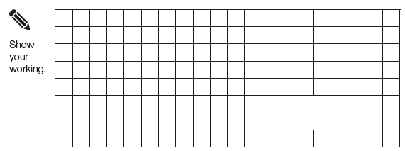
What is the cost in pence of 1 bag of crisps?
£3.00 - £0.39 = £2.61
£2.61 ÷ 3 = £0.87
£0.87 = 87p

87p
(1 mark)

3. This is an addition pyramid. The total in a box is made by adding the two boxes underneath. Use this rule to find the missing numbers.

DAY 2
Reasoning Questions

2,419
1,535
1,563
3,098
3,982
7,080

(1 mark)

4. Write the missing number
77
÷ 8 = 9 remainder 5
(1 mark)
5. Tourists to Thorpe Park theme park can get on the largest rollercoaster in groups of 31. If there are 6,762 visitors visiting on one day, how many times does the rollercoaster have to run for all visitors to go on the ride once?
1 31 6 186
2 62 7 217
3 93 8 248
4 124 10 310
5 155

6762 ÷ 31
0218^{r4}
31 6762

219

(2 marks)

DAY 3
Arithmetic Questions
92 x 36 =

3,312

32.6 + ________ = 41.97
6² =

72
9.37
1,000
36
20% x 360 =
1.9 ÷ _______ = 0.0019
45.6 x _____ = 4560
45.6 x _____ = 4560
1. Circle all the fractions equivalent to $\frac{3}{4}$:
$\frac{3}{12}$ $\frac{15}{20}$ $\frac{6}{9}$ $\frac{30}{40}$ $\frac{12}{20}$

(1 mark)
2. Sally is doing a charity cycle. She cycles 3 $\frac{2}{5}$ miles in the morning and 2 $\frac{1}{3}$ miles in the afternoon.
How far was her charity cycle?

5 $\frac{11}{15}$ miles

(1 mark)
3. Write one number in each box to make these fraction sentences correct.
3
= 1 = 5
20
12 4
2 + 2 = 6
5
10
10
DAY 3
Reasoning Questions

4. My cats eat $\frac{3}{5}$ of a tin of cat food a day. How many tins will I need to buy to last them one week?
3 x 7 = 21
5 5
21 = 4 1/5
5

5
(1 mark)

5. Tim uses $\frac{5}{6}$ of this chocolate bar. Shade the number of chocolate squares he has used.

(1 mark)

16 x 4 + (19 – 8) =
DAY 4
Arithmetic Questions

75

5³ – 3² =
_______ = $\frac{3}{4}$ x 200
$\frac{2}{3}$ or $\frac{4}{6}$
_______ - $\frac{2}{6}$ = $\frac{1}{3}$
437^{r11}
116
150
5,692 ÷ 13 =
45.6 x _____ = 4560
45.6 x _____ = 4560
1. Find the value of the symbols.
DAY 4
Reasoning Questions
+ + = 18
- = 2
X = 30

= ____8____ = ____6____ = ___5___
(1 mark)
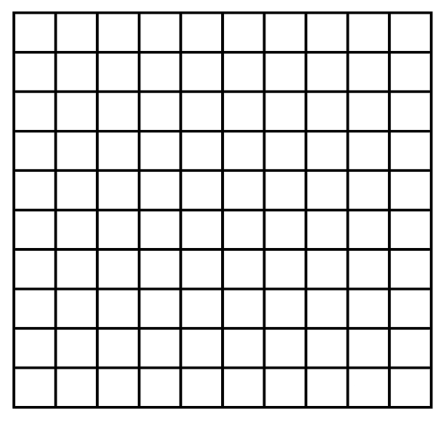
2. Reflect the shape in the mirror line.

(1 mark)

3. 3y + x = 24
7
When x = 3 y =
12
When y = 4 x = (1 mark)

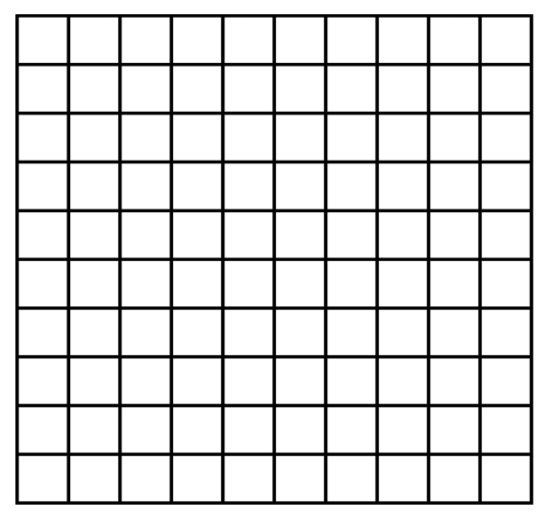
4. Translate the shape 3 squares left and 4 squares up.

(1 mark)

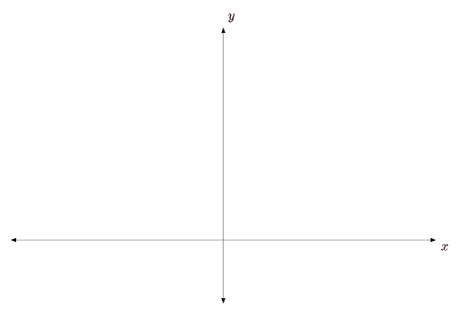
5. Here is a line on a coordinate grid.
C
B
A
O

Points O, A, B and C are equally spaced. The coordinates of A are (12,15). What are the coordinates of point C?
___(36, 45)__ (1 mark)
263,592 + _________ = 274,592
DAY 5
Arithmetic Questions

11,000

$\frac{5}{9}$ x 8 =
_____ = 6 x 3 x 7
11.8
4 $\frac{4}{9}$
1,400
126
2.36 x 5 =
35% of 4,000 =
45.6 x _____ = 4560
45.6 x _____ = 4560
1. Complete this table by rounding the numbers to the nearest whole number.
DAY 5
Reasoning Questions
DAY 5
Reasoning Questions
Number | Rounded to the nearest whole number
29.1 | 29
38.6 | 39
42.5 | 43
30.4 | 30
(1 mark)
2. Write these numbers in ascending order.
7 6.26 6.106 6.7 6.666
7
6.7
6.666
6.26
6.106

^{smallest} ^{largest} (1 mark)
3. Tick (✔️) all the numbers which represent the shaded part of the diagram.
4 $\frac{2}{5}$ ✔️ 0.04 4% 0.4 ✔️
(1 mark)

4. Bobby has £69 to spend on new clothes.
He buys 3 packs of socks and 2 pairs of jogging bottoms. How much does he have left to spend on t-shirts?
jogging bottoms £7.95
t-shirts £4.55
packs of socks £2.99
£2.99 x 3 = £8.97
£7.95 + £7.95 = £15.90
£15.90 + £8.97 = £24.87
£69.00 - £24.87 = £44.13

£44.13

(1 mark)
5. Match each fraction to its equivalent decimal or percentage.
$\frac{1}{10}$ 30% $\frac{2}{5}$
0.15
0.01
$\frac{3}{20}$ 0.25 $\frac{15}{50}$
40%
10%

45.6 x _____ = 4560
45.6 x _____ = 4560

(1 mark)
45.6 x _____ = 4560
45.6 x _____ = 4560

