‘6 for 6’ Writing Holiday Challenge
This booklet is designed to keep your brains ‘ticking over’ during the long summer break. Just a few short activities will mean that you return to Year 6 ready to learn and raring to go! Try to really impress your teacher by completing one challenge for each week of the holidays. Circle any activities that you’d like some more help with when term starts again.

Commissioned by The PiXL Club Ltd.
2017


This resource is strictly for the use of member schools for as long as they remain members of The PiXL Club. It may not be copied, sold nor transferred to a third party or used by the school after membership ceases. Until such time it may be freely used within the member school.
All opinions and contributions are those of the authors. The contents of this resource are not connected with nor endorsed by any other company, organisation or institution.

© Copyright The PiXL Club Limited, 2017



This resource is designed to give you weekly opportunities during the summer holidays to consolidate all that you have learnt so far. You are not expected to write full texts, or to write for long periods of time. However, you should use this as an opportunity to show off to your teachers.
The table below explains what type of writing you will be thinking about each week and what the focus of this writing is. Make sure you consider this before you start writing.
Week | Stimulus | Type of writing | Focus
1 | The first week of my holidays | First person diary entry | Consistent use of perspective (1st person)
2 | My ultimate bedroom | Setting description | Language choices and variety of sentence structure.
3 | How to get fit | Explanation text | Organisation of writing. Variety of sentence openers.
4 | Tea with the Queen | Dialogue | Balance between dialogue and description. Correctly punctuated dialogue.
5 | A letter to my hero | Letter | Use of appropriate language. Organisation.
6 | Why we should have an extra week of holiday | Persuasive text | Paragraphing. Emotive language. Formal language/tone.
The next page gives you some useful resources that you may or may not choose to use to support your writing. Make sure you think about the presentation and accuracy of your work. Teachers always recognise and reward effort.

Year 5/6 Spelling list
accommodate  accompany  according  achieve  aggressive  amateur  ancient  apparent  appreciate  attached  available  average  awkward  bargain  bruise  category  cemetery  committee  communicate  community  competition  conscience*  conscious*  controversy  convenience  correspond | criticise (critic + ise)  curiosity definite  desperate  determined  develop  dictionary  disastrous  embarrass  environment  equip (–ped, –ment)  especially  exaggerate  excellent  existence  explanation  familiar  foreign  forty  frequently  government  guarantee  harass  hindrance | identity  immediate(ly)  individual  interfere  interrupt  language  leisure  lightning  marvellous  mischievous  muscle  necessary  neighbour  nuisance  occupy  occur  opportunity  parliament  persuade  physical  prejudice  privilege  profession  programme  pronunciation  queue | recognise  recommend  relevant  restaurant  rhyme  rhythm sacrifice  secretary  shoulder  signature  sincere(ly)  soldier  stomach  sufficient  suggest  symbol  system  temperature  thorough  twelfth  variety  vegetable  vehicle  yacht
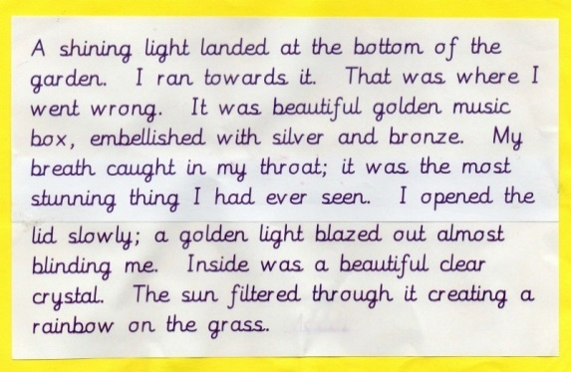
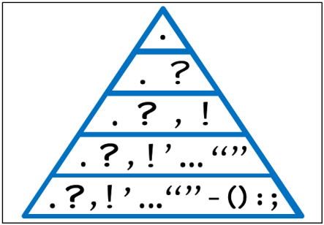
Punctuation
Handwriting reminder
Pyramid

Writing Week 1

The first week of the summer holiday is always the best. Time to rest, relax and bask in the glory of lie-ins, fun things and generally enjoying a proper break. At the end of this first week, write a first person diary entry to tell your diary how fabulous it was and what you have in store, or hope to do, for the rest of the holiday.
Use this box to plan what you are going to write, including key language you want to include:

Focus: Consistent use of tense.
Focus: Consistent use of first person perspective.
Task: Write a short diary entry, explaining what you have done in the first week of the holidays and what else is coming up.
____________________________________________________________________________________________________________________________________________________________________________________________________________________________________________________________________________________________________________________________________________________________________________________________________________________________________________________________________________________________________________________________________________________________________________________________________________________________________________________________________________________________________________________________________________________________________________________________________________________________________________________________________________________________________________________________________________________________________________________________________________________________________________________________________________________________________________________________________________________________________________________________________________________________________________________________________________________________________________________________________________________________________________________________________________________________________________________________________________________________________________________________________________________________
Writing Week 2
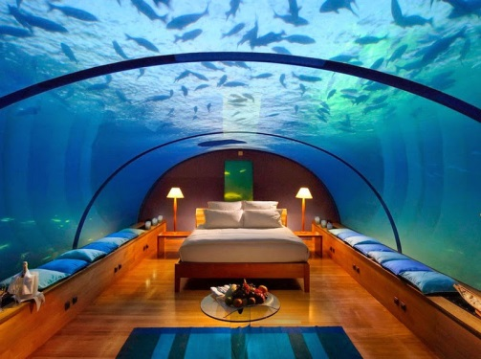
Imagine you had all the money in the world and you were asked to design your ultimate bedroom. Would it be built like a treehouse? Have slides into the bed? Be under the sea? You can be as creative and imaginative as you like. Describe this bedroom in precise detail, being certain to use powerful language that really grabs the attention of the reader.
Use this box to plan what you are going to write, including key language you want to include:

Focus: Consistent use of tense.
Focus: Language choices and variety of sentence structure.
Task: Write a description of your ultimate bedroom.
____________________________________________________________________________________________________________________________________________________________________________________________________________________________________________________________________________________________________________________________________________________________________________________________________________________________________________________________________________________________________________________________________________________________________________________________________________________________________________________________________________________________________________________________________________________________________________________________________________________________________________________________________________________________________________________________________________________________________________________________________________________________________________________________________________________________________________________________________________________________________________________________________________________________________________________________________________________________________________________________________________________________________________________________________________________________________________________________________________________________________________________________________________________________
Writing Week 3

We all know how important keeping fit and healthy is. The summer holidays are a great time to increase the amount of exercise that you do and perhaps to try a new sport or activity. Write a short explanation of how to improve your fitness, using the headings below.
Use this box to plan what you are going to write, including key language you want to include:

Focus: Consistent use of tense.
Focus: Organisation of writing. Variety of sentence openers.
Task: Write an explanation of how to improve your fitness.
Why is exercise important? ______________________________________________________________________________________________________________________________________________________________________________________________________________________________________________________________________________________________________________________________________________________________
What you need to get started:

How can you improve your fitness? __________________________________________________________________________________________________________________________________________________________________________________________________________________________________________________________________________________________________________________________________________________________________________________________________________________________________________________________________ What are the positive effects of exercise?
______________________________________________________________________________________________________________________________________________________________________________________________________________________________________________________________________________________________________________________________________________________________
Writing Week 4

What do you think the Queen talks about over tea? Does she discuss the weather or how her day was? Perhaps she tells Prince Charles off for leaving wet towels in the bathroom? Imagine that the Queen is having tea with her family. Write the conversation that you think they might be having. Remember to include descriptive sentences too, to give the reader more detail.
Use this box to plan what you are going to write, including key language you want to include:

Focus: Consistent use of tense.
Focus: Accurate punctuation of dialogue. Balance of description and dialogue.
Task: Write a conversation between the Queen and her family, over tea.
__________________________________________________________________________________________________________________________________________________________________________________________________________________________________________________________________________________________________________________________________________________________________________________________________________________________________________________________________________________________________________________________________________________________________________________________________________________________________________________________________________________________________________________________________________________________________________________________________________________________________________________________________________________________________________________________________________________________________________________________________________________________________________________________________________________________________________________________________________________________________________________________________________________________________________________________________________________________________________________________________________________________________________________________________________________________________________________________________________________________________________
Writing Week 5

Who is your hero? Why are they your hero? What would you say to them if you got the chance? Write a letter to your hero, explaining who you are and why they are your hero. Talk about how they have influenced your life and your hopes for the future.
Use this box to plan what you are going to write, including key language you want to include:

Focus: Consistent use of tense.
Focus: Use of appropriate language. Overall organisation of a text.
Task: Write a letter to your hero.
________________________________________________________________________________________________________________________________________________________________________________________________________________________________________________________________________________________________________________________________________________________________________________________________________________________________________________________________________________________________________________________________________________________________________________________________________________________________________________________________________________________________________________________________________________________________________________________________________________________________________________________________________________________________________________________________________________________________________________________________________________________________________________________________________________________________________________________________________________________________________________________________________________________________________________________________________________________________________________________________________________________________________________________________________________________________________________________________________________________________________________________________________________________________________________________________________________________________________________________________
Writing Week 6

It is the end of the summer holidays. Why do they never feel long enough? What if you could persuade your teachers to give you an extra week off? Come up with three key reasons that you deserve an extra week of holiday. Explain these reasons and use your language choices to encourage your teacher to agree with you!
Use this box to plan what you are going to write, including key language you want to include:

Focus: Consistent use of tense.
Focus: Use of paragraphs. Inclusion of emotive language.
Task: Persuade your teacher to give you an extra week off, in three paragraphs.
____________________________________________________________________________________________________________________________________________________________________________________________________________________________________________________________________________________________________________________________________________________________________________________________________________________________________________________________________________________________________________________________________________________________________________________________________________________________________________________________________________________________________________________________________________________________________________________________________________________________________________________________________________________________________________________________________________________________________________________________________________________________________________________________________________________________________________________________________________________________________________________________________________________________________________________________________________________________________________________________________________________________________________________________________________________________________________________________________________________________________________________________________________________________

