Common Exception Words

Family 20: sure, sugar, who, whole, hour

Commissioned by The PiXL Club Ltd.
October 2018
This resource is strictly for the use of member schools for as long as they remain members of The PiXL Club. It may not be copied, sold nor transferred to a third party or used by the school after membership ceases. Until such time it may be freely used within the member school.
All opinions and contributions are those of the authors. The contents of this resource are not connected with nor endorsed by any other company, organisation or institution.
PiXL Club Ltd endeavour to trace and contact copyright owners. If there are any inadvertent omissions or errors in the acknowledgements or usage, this is unintended and PiXL will remedy these on written notification.

© Copyright The PiXL Club Limited, 2018
Common Exception Words – Family 20

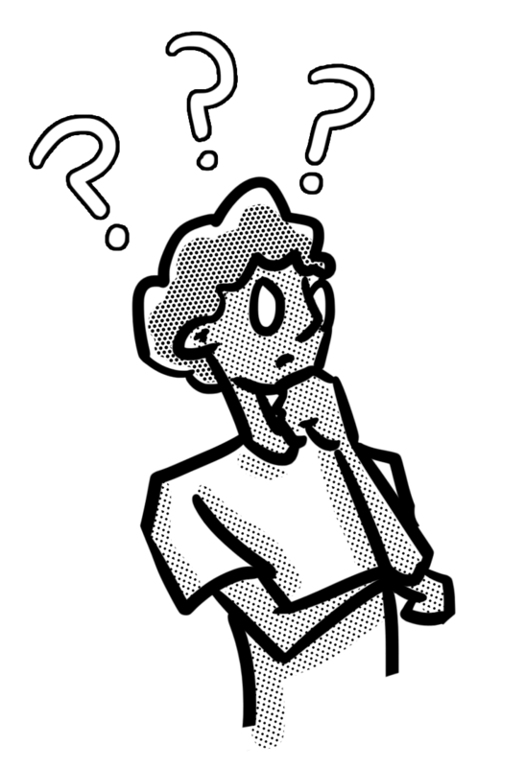
Word 1: sure
Meaning: sure means certain.
Example: Are you sure you can do it?
Your example: ________________________________________________
Trick: u r sure

Now practise:

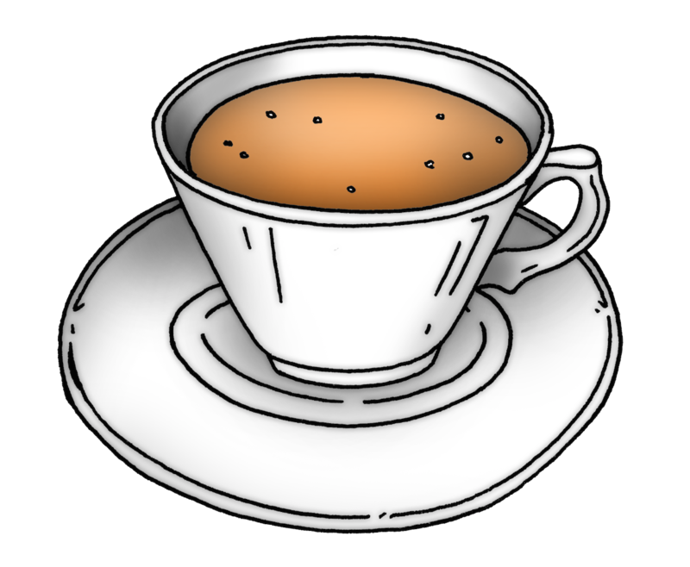
Word 2: sugar
Meaning: sugar is a sweet, grainy substance.
Example: She likes to have sugar in her tea.
Your example: ________________________________________________
Trick: s u gar

Now practise:

Word 3: who
?
Meaning: who means which person.
Example: Who were you talking to?
Your example:
________________________________________________
Trick: w – hooo!

Now practise:

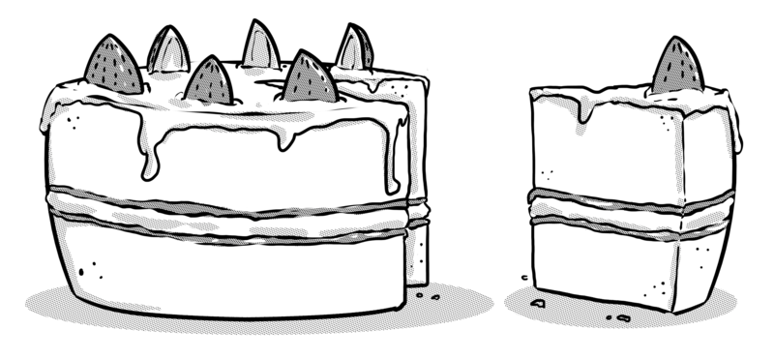
Word 4: whole
Meaning: whole means the entire thing.
Example: Don’t eat the whole cake!
Your example: ________________________________________________
Trick: w – hole

Now practise:

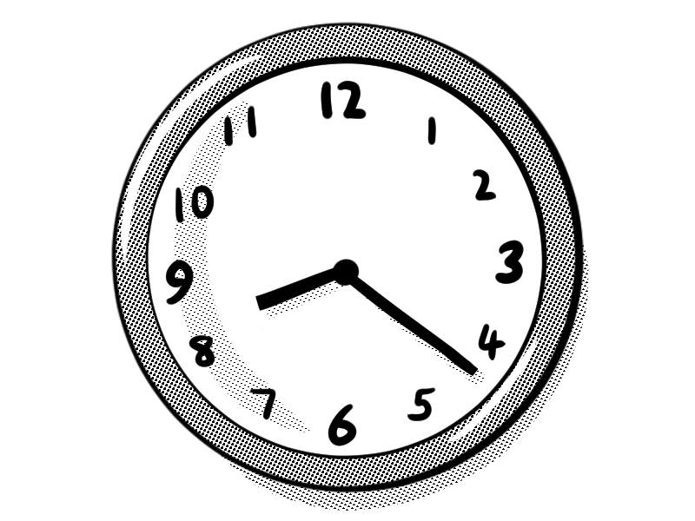
Word 5: hour
Meaning: an hour is a period of sixty minutes.
Example: We’ll be there in less than an hour.
Your example: ________________________________________________
Trick: h – our

Now practise:

