Common Exception Words

Family 18: fast, last, past, ask

Commissioned by The PiXL Club Ltd.
October 2018
This resource is strictly for the use of member schools for as long as they remain members of The PiXL Club. It may not be copied, sold nor transferred to a third party or used by the school after membership ceases. Until such time it may be freely used within the member school.
All opinions and contributions are those of the authors. The contents of this resource are not connected with nor endorsed by any other company, organisation or institution.
PiXL Club Ltd endeavour to trace and contact copyright owners. If there are any inadvertent omissions or errors in the acknowledgements or usage, this is unintended and PiXL will remedy these on written notification.

© Copyright The PiXL Club Limited, 2018
Common Exception Words – Family 18

Word 1: fast
Meaning: fast means quick or at speed.
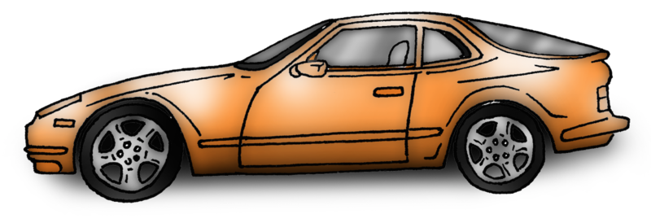
Example: She drove a fast car.
Your example: ________________________________________________
Trick: as fast

Now practise:

Word 2: last
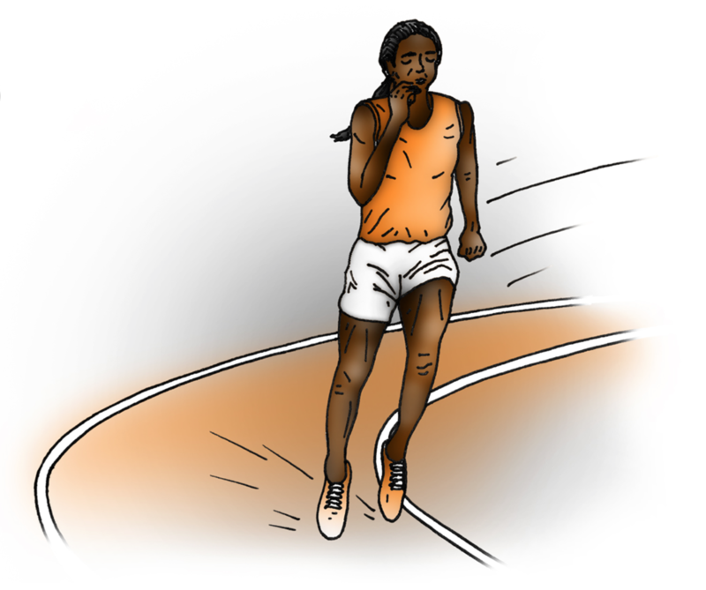
Meaning: last means in the final position or remain unchanged.
Example: I came last in the race.
Your example: ________________________________________________
Trick: l as t

Now practise:

Word 3: past
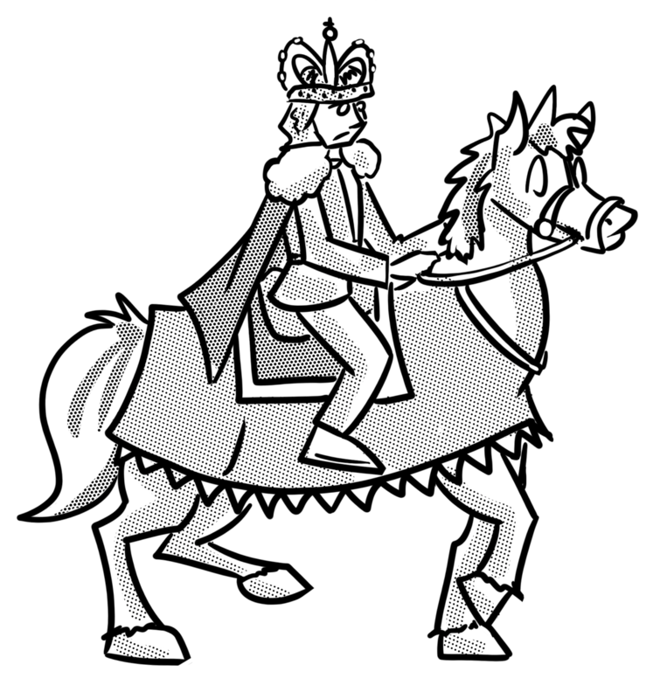
Meaning: past means finished or in the time before now.
Example: History happened in the past.
Your example: ________________________________________________
Trick: p as t

Now practise:

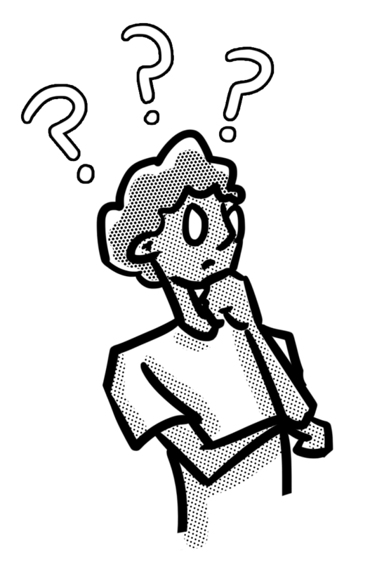
Word 4: ask
Meaning: ask means speak or write to get an answer.
Example: Ask me any question.
Your example: ________________________________________________
Trick: as k

Now practise:

