Common Exception Words

Family 17: path, bath, father

Commissioned by The PiXL Club Ltd.
October 2018
This resource is strictly for the use of member schools for as long as they remain members of The PiXL Club. It may not be copied, sold nor transferred to a third party or used by the school after membership ceases. Until such time it may be freely used within the member school.
All opinions and contributions are those of the authors. The contents of this resource are not connected with nor endorsed by any other company, organisation or institution.
PiXL Club Ltd endeavour to trace and contact copyright owners. If there are any inadvertent omissions or errors in the acknowledgements or usage, this is unintended and PiXL will remedy these on written notification.

© Copyright The PiXL Club Limited, 2018
Common Exception Words – Family 17

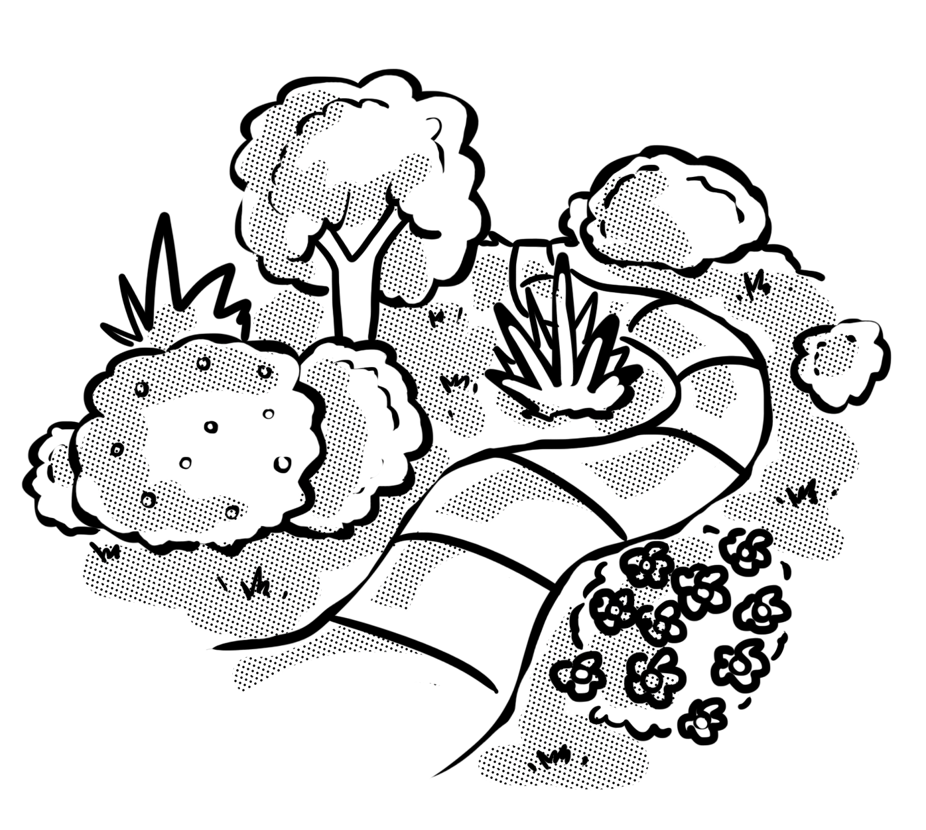
Word 1: path
Meaning: path means route or footway.
Example: The garden path was overgrown.
Your example: ________________________________________________
Trick: pat the path

Now practise:

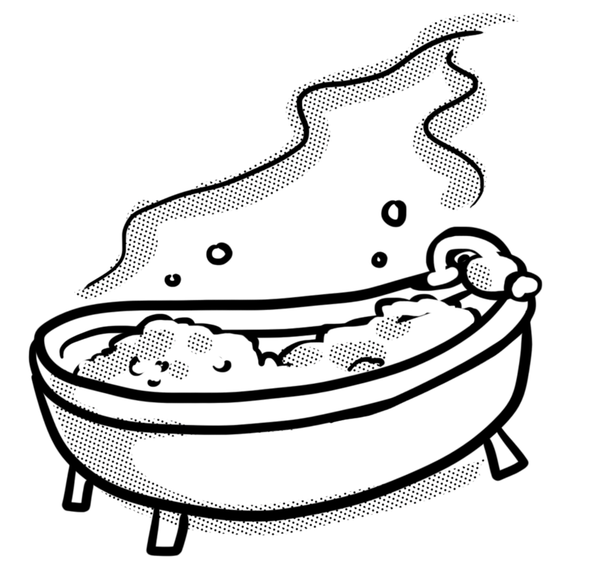
Word 2: bath
Meaning: a bath is a large tub of water for washing.
Example: I had a nice hot bath.
Your example: ________________________________________________
Trick: there’s a bat in the bath

Now practise:

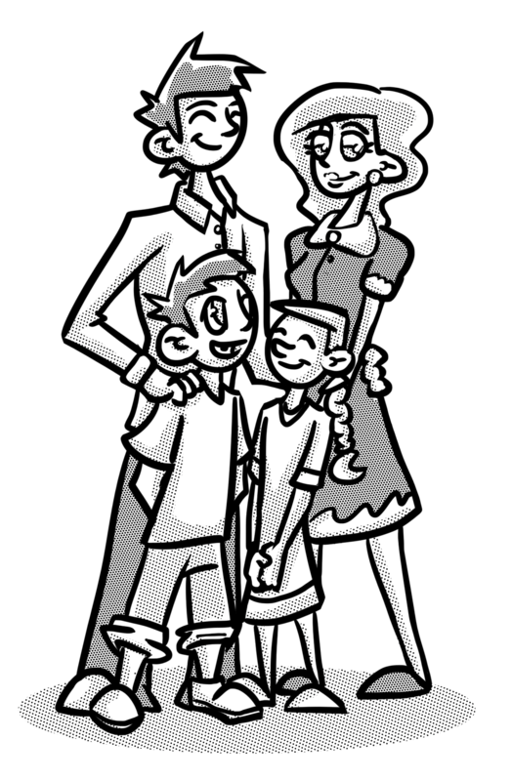
Word 3: father
Meaning: father means the male parent.
Example: Her father was always happy.
Your example: ________________________________________________
Trick: fat – her

Now practise:

