Common Exception Words

Family 16: great, break, steak

Commissioned by The PiXL Club Ltd.
October 2018
This resource is strictly for the use of member schools for as long as they remain members of The PiXL Club. It may not be copied, sold nor transferred to a third party or used by the school after membership ceases. Until such time it may be freely used within the member school.
All opinions and contributions are those of the authors. The contents of this resource are not connected with nor endorsed by any other company, organisation or institution.
PiXL Club Ltd endeavour to trace and contact copyright owners. If there are any inadvertent omissions or errors in the acknowledgements or usage, this is unintended and PiXL will remedy these on written notification.

© Copyright The PiXL Club Limited, 2018
Common Exception Words – Family 16

Word 1: great

Meaning: great means large or impressive.
Example: That is a great idea!
Your example: ________________________________________________
Trick: eat something great

Now practise:

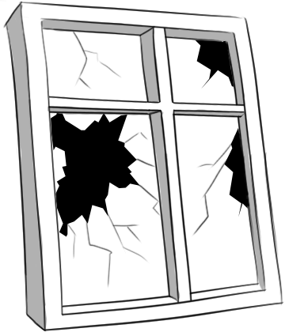
Word 2: break
Meaning: break means to split, damage or rest.
Example: Did you break the window?
Your example: ________________________________________________
Trick: bre – ak

Now practise:

Word 3: steak
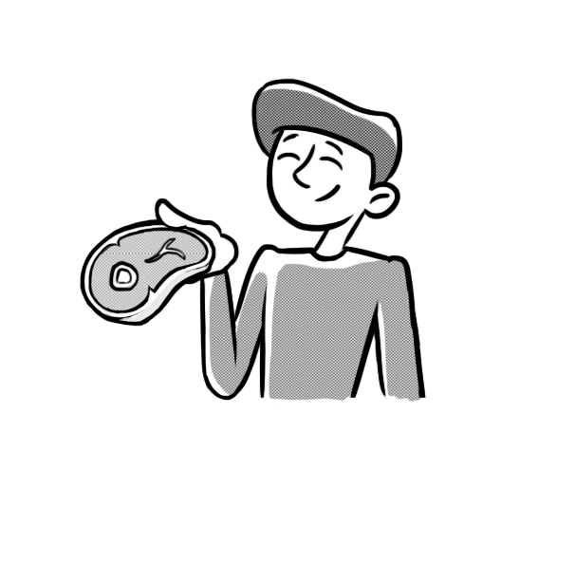
Meaning: a steak is a cut of meat.
Example: He had steak and chips for tea.
Your example: ________________________________________________
Trick: eat steak

Now practise:

