Common Exception Words

Family 14: child, children, wild, climb

Commissioned by The PiXL Club Ltd.
October 2018
This resource is strictly for the use of member schools for as long as they remain members of The PiXL Club. It may not be copied, sold nor transferred to a third party or used by the school after membership ceases. Until such time it may be freely used within the member school.
All opinions and contributions are those of the authors. The contents of this resource are not connected with nor endorsed by any other company, organisation or institution.
PiXL Club Ltd endeavour to trace and contact copyright owners. If there are any inadvertent omissions or errors in the acknowledgements or usage, this is unintended and PiXL will remedy these on written notification.

© Copyright The PiXL Club Limited, 2018
Common Exception Words – Family 14

Word 1: child

Meaning: a child is a young human.
Example: She is just a child.
Your example: ________________________________________________
Trick: i l be a child

Now practise:

Word 2: children
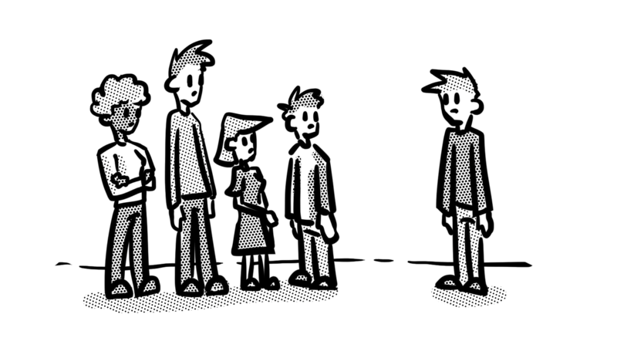
Meaning: children means more than one young human.
Example: There are thirty children in my class.
Your example: ________________________________________________
Trick: chil – dren

Now practise:

Word 3: wild
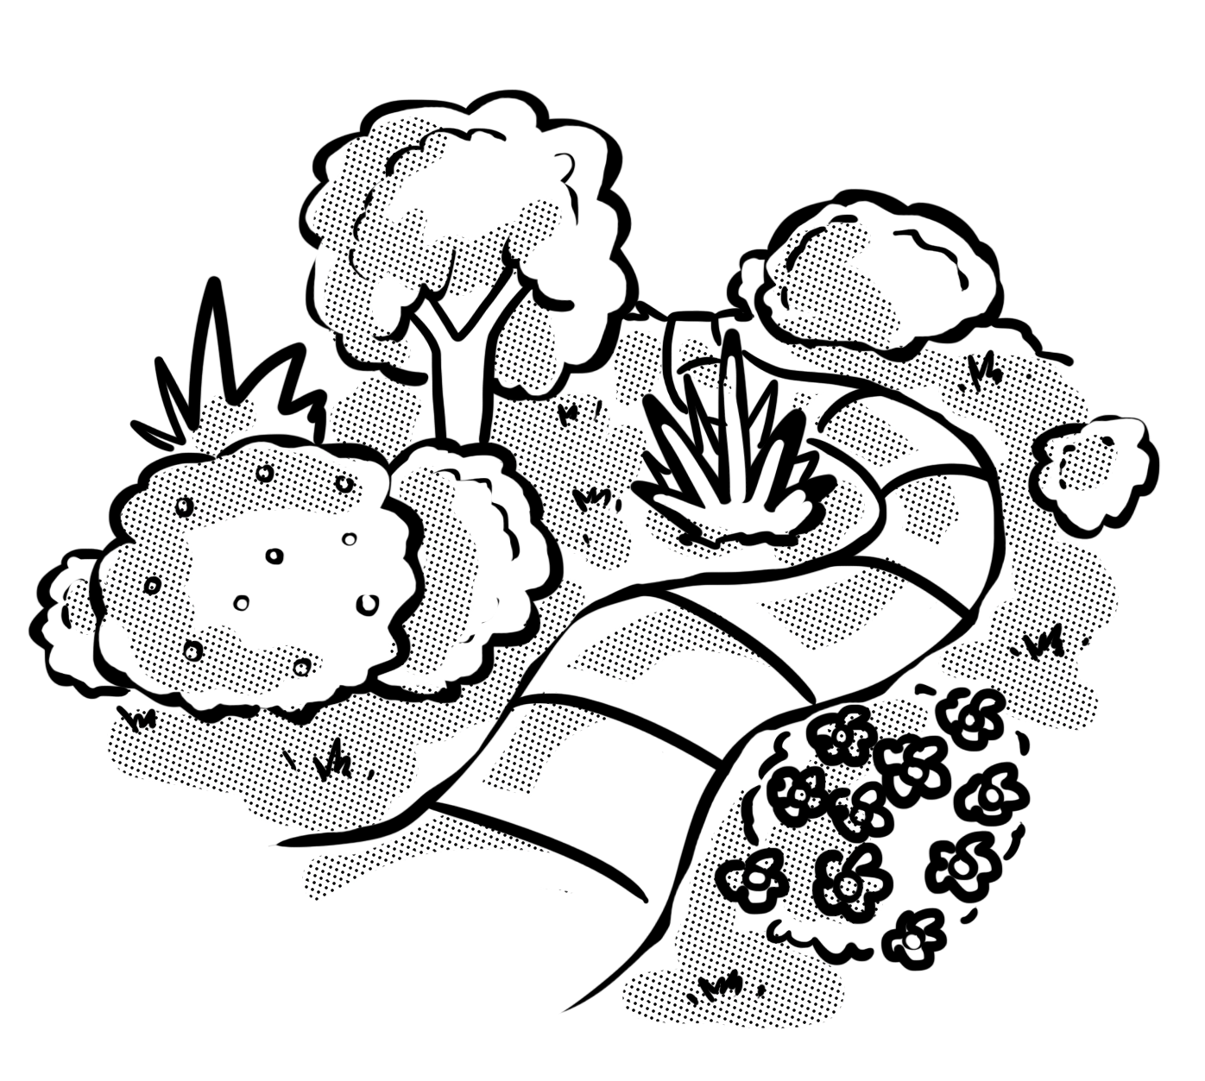
Meaning: wild means natural or not tame.
Example: He found a field of wild flowers.
Your example: ________________________________________________
Trick: I l be wild

Now practise:

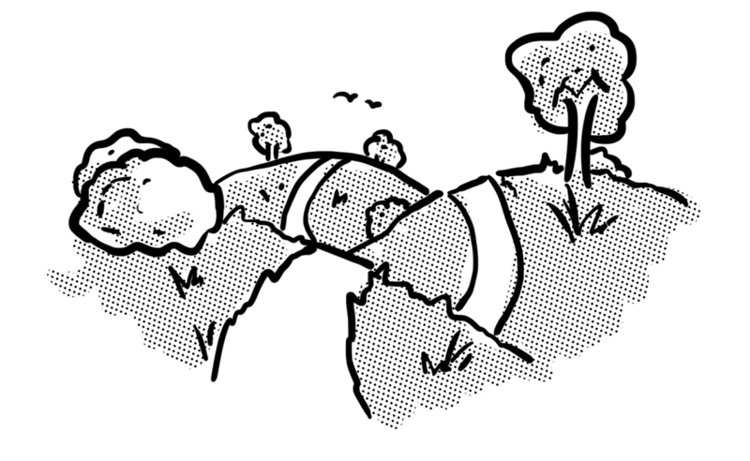
Word 4: climb
Meaning: climb means to move upwards.
Example: Let’s climb this hill.
Your example: ________________________________________________
Trick: clim – b

Now practise:

