Common Exception Words

Family 13: find, kind, mind, behind

Commissioned by The PiXL Club Ltd.
October 2018
This resource is strictly for the use of member schools for as long as they remain members of The PiXL Club. It may not be copied, sold nor transferred to a third party or used by the school after membership ceases. Until such time it may be freely used within the member school.
All opinions and contributions are those of the authors. The contents of this resource are not connected with nor endorsed by any other company, organisation or institution.
PiXL Club Ltd endeavour to trace and contact copyright owners. If there are any inadvertent omissions or errors in the acknowledgements or usage, this is unintended and PiXL will remedy these on written notification.

© Copyright The PiXL Club Limited, 2018
Common Exception Words – Family 13

Word 1: find

Meaning: find means to locate or discover.
Example: I can’t find it.
Your example: ________________________________________________
Trick: f in d

Now practise:

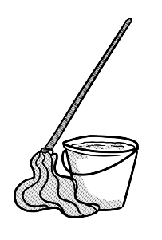
Word 2: kind
Meaning: kind means being thoughtful or helpful.
Example: How kind of you to help clean up!
Your example: ________________________________________________
Trick: k in d

Now practise:

Word 3: mind

Meaning: your mind refers to your thoughts and cleverness.
Example: She has a very sharp mind.
Your example: ________________________________________________
Trick: m in d

Now practise:

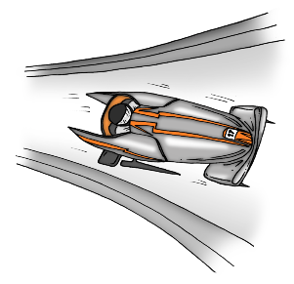
Word 4: behind
Meaning: behind means in a position further back.
Example: He finished just behind the winner.
Your example: ________________________________________________
Trick: be- h in d

Now practise:

