Common Exception Words

Family 12: door, floor, poor

Commissioned by The PiXL Club Ltd.
October 2018
This resource is strictly for the use of member schools for as long as they remain members of The PiXL Club. It may not be copied, sold nor transferred to a third party or used by the school after membership ceases. Until such time it may be freely used within the member school.
All opinions and contributions are those of the authors. The contents of this resource are not connected with nor endorsed by any other company, organisation or institution.
PiXL Club Ltd endeavour to trace and contact copyright owners. If there are any inadvertent omissions or errors in the acknowledgements or usage, this is unintended and PiXL will remedy these on written notification.

© Copyright The PiXL Club Limited, 2018
Common Exception Words – Family 12

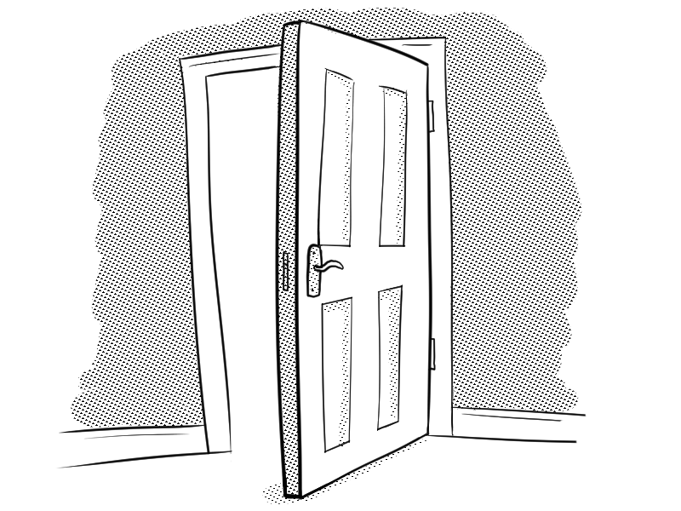
Word 1: door
Meaning: door means the opening to a room.
Example: Please close the door behind you.
Your example: ________________________________________________
Trick: d oo r

Now practise:

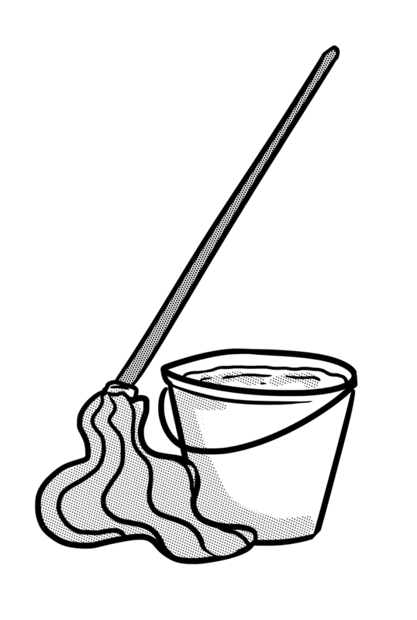
Word 2: floor
Meaning: floor means the lower surface inside a room.
Example: Mop the floor.
Your example: ________________________________________________
Trick: fl oo r

Now practise:

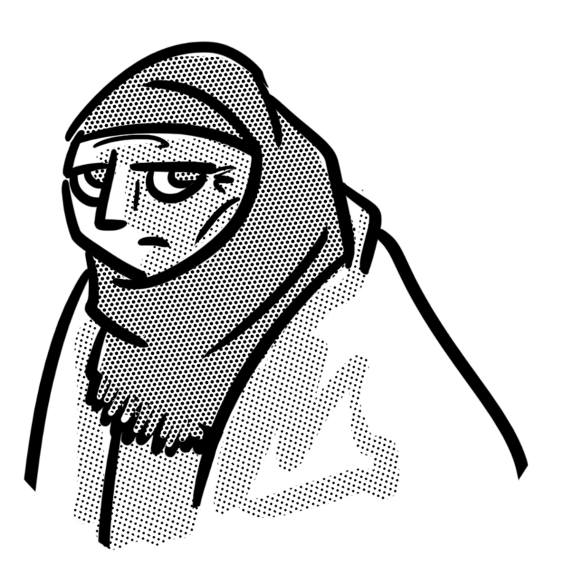
Word 3: poor
Meaning: poor means not having much money.
Example: She was too poor to buy new shoes.
Your example: ________________________________________________
Trick: p oo r

Now practise:

