Common Exception Words

Family 11: of, eye, even, school, water

Commissioned by The PiXL Club Ltd.
October 2018
This resource is strictly for the use of member schools for as long as they remain members of The PiXL Club. It may not be copied, sold nor transferred to a third party or used by the school after membership ceases. Until such time it may be freely used within the member school.
All opinions and contributions are those of the authors. The contents of this resource are not connected with nor endorsed by any other company, organisation or institution.
PiXL Club Ltd endeavour to trace and contact copyright owners. If there are any inadvertent omissions or errors in the acknowledgements or usage, this is unintended and PiXL will remedy these on written notification.

© Copyright The PiXL Club Limited, 2018
Common Exception Words – Family 11


Word 1: of
Meaning: of is used to suggest belonging or a link.
Example: It was a good idea of yours.
Your example: ________________________________________________
Trick: o f

Now practise:

Word 2: eye
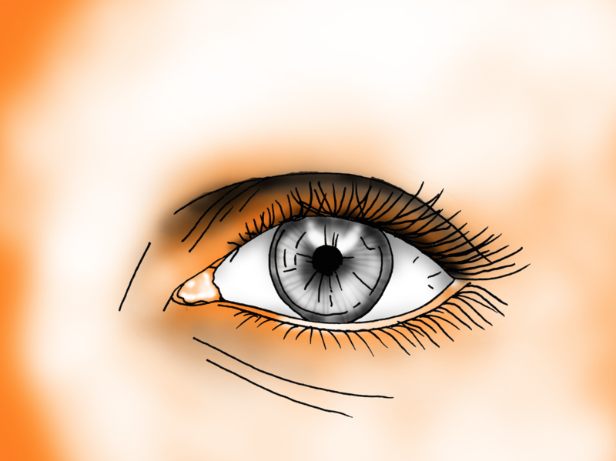
Meaning: eye means the organ used for seeing.
Example: She kept one eye open.
Your example: ________________________________________________
Trick: eye see two ‘e’s

Now practise:

Word 3: even

Meaning: even means level, regular or fair. It can also be used to suggest strangeness.
Example: It was a very even game.
Your example: ________________________________________________
Trick: two ‘e’s get even

Now practise:

Word 4: school

Meaning: school means a building where children learn.
Example: We all learn at school.
Your example: ________________________________________________
Trick: sc hoo l

Now practise:

Word 5: water
Meaning: water means the clear liquid essential for life.
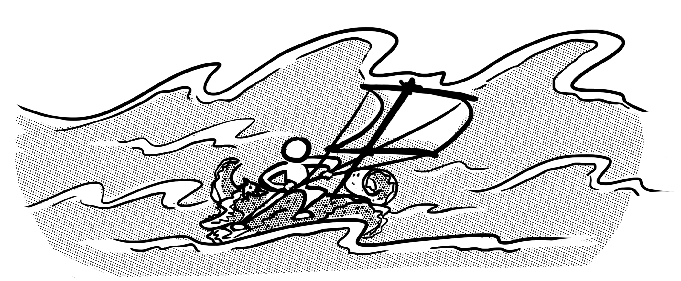
Example: The sea is made of water.
Your example: ________________________________________________
Trick: wat er

Now practise:

