Common Exception Words

Family 10: house, our, you, your

Commissioned by The PiXL Club Ltd.
October 2018
This resource is strictly for the use of member schools for as long as they remain members of The PiXL Club. It may not be copied, sold nor transferred to a third party or used by the school after membership ceases. Until such time it may be freely used within the member school.
All opinions and contributions are those of the authors. The contents of this resource are not connected with nor endorsed by any other company, organisation or institution.
PiXL Club Ltd endeavour to trace and contact copyright owners. If there are any inadvertent omissions or errors in the acknowledgements or usage, this is unintended and PiXL will remedy these on written notification.

© Copyright The PiXL Club Limited, 2018
Common Exception Words – Family 10

Word 1: house
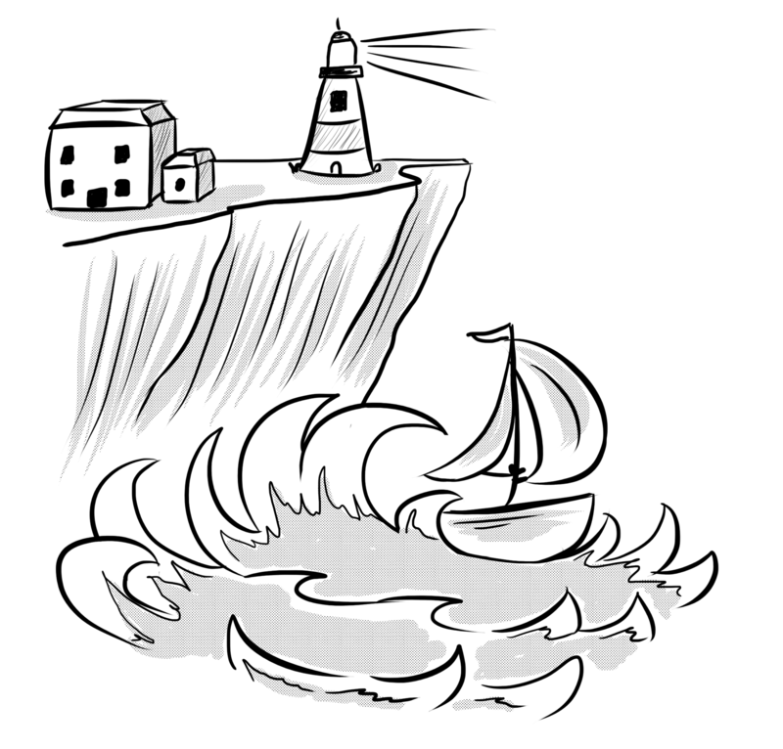
Meaning: house means a building where people live.
Example: Is this your house?
Your example: ________________________________________________
Trick: o u are in the house

Now practise:

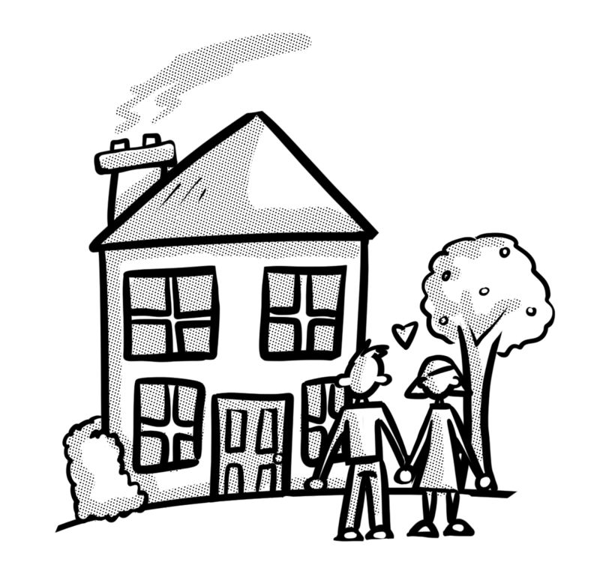
Word 2: our
Meaning: our means belonging to us.
Example: This is our house.
Your example: ________________________________________________
Trick: o u r ours

Now practise:


Word 3: you
Meaning: you means the person or persons being spoken to.
Example: I’m talking to you.
Your example: ________________________________________________
Trick: y-o-u

Now practise:


Word 4: your
Meaning: your means belonging to you.
Example: Is this your money?
Your example: ________________________________________________
Trick: Is it ours or yours?

Now practise:

