Common Exception Words

Family 9: friend, said, says, again

Commissioned by The PiXL Club Ltd.
October 2018
This resource is strictly for the use of member schools for as long as they remain members of The PiXL Club. It may not be copied, sold nor transferred to a third party or used by the school after membership ceases. Until such time it may be freely used within the member school.
All opinions and contributions are those of the authors. The contents of this resource are not connected with nor endorsed by any other company, organisation or institution.
PiXL Club Ltd endeavour to trace and contact copyright owners. If there are any inadvertent omissions or errors in the acknowledgements or usage, this is unintended and PiXL will remedy these on written notification.

© Copyright The PiXL Club Limited, 2018
Common Exception Words – Family 9

Word 1: friend
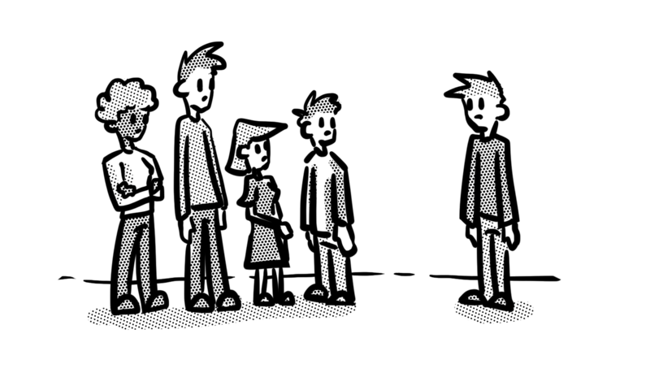
Meaning: friend means a person who is seen as liked, loyal and an ally.
Example: My friend helped me.
Your example: ________________________________________________
Trick: fri – end to the end

Now practise:


Word 2: said
Meaning: said means it has been spoken.
Example: ‘Welcome home,’ I said.
Your example: ________________________________________________
Trick: a I said that

Now practise:


Word 3: says
Meaning: says means speaks or is speaking.
Example: She says she’s ready.
Your example:
________________________________________________
Trick: s-ay-s

Now practise:


Word 4: again
Meaning: again means another or second time.
Example: He won again.
Your example: ________________________________________________
Trick: a I went again

Now practise:

