Common Exception Words

Family 7: put, push, pull, full

Commissioned by The PiXL Club Ltd.
October 2018
This resource is strictly for the use of member schools for as long as they remain members of The PiXL Club. It may not be copied, sold nor transferred to a third party or used by the school after membership ceases. Until such time it may be freely used within the member school.
All opinions and contributions are those of the authors. The contents of this resource are not connected with nor endorsed by any other company, organisation or institution.
PiXL Club Ltd endeavour to trace and contact copyright owners. If there are any inadvertent omissions or errors in the acknowledgements or usage, this is unintended and PiXL will remedy these on written notification.

© Copyright The PiXL Club Limited, 2018
Common Exception Words – Family 7

Word 1: put
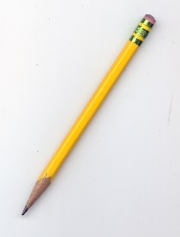
Meaning: put means to cause to be in a place.
Example: Put your pencil down.
Your example: ________________________________________________
Trick: put u in

Now practise:

Word 2: push
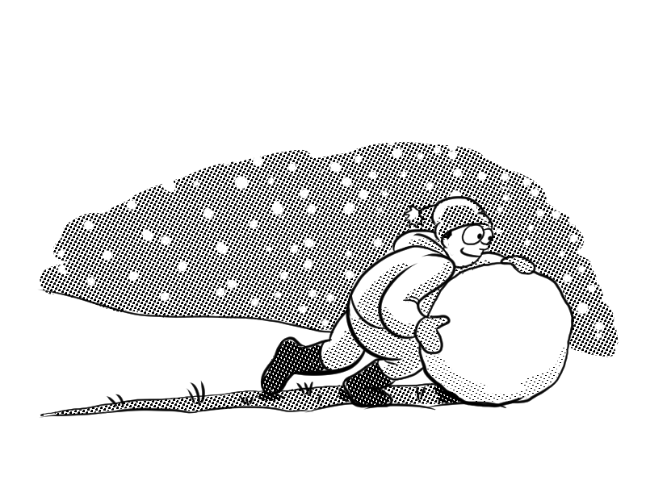
Meaning: push means apply force to make something move.
Example: Push the snowball.
Your example: ________________________________________________
Trick: push u in

Now practise:

Word 3: pull

Meaning: pull means apply a force that draws it closer.
Example: Pull the rope.
Your example: ________________________________________________
Trick: pull u in

Now practise:

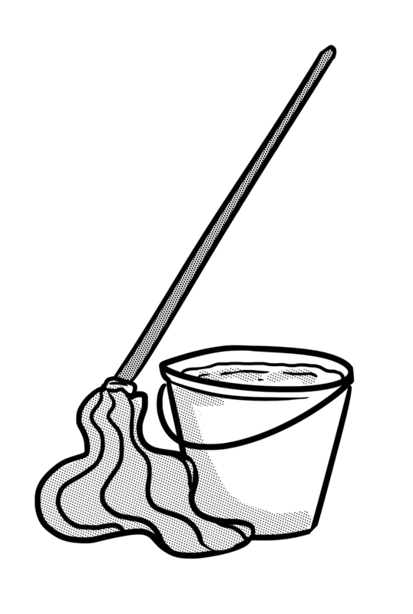
Word 4: full
Meaning: full means containing as much as possible.
Example: The bucket is full.
Your example: ________________________________________________
Trick: full of u

Now practise:

