Common Exception Words

Family 5: is, his, has, was, busy

Commissioned by The PiXL Club Ltd.
October 2018
This resource is strictly for the use of member schools for as long as they remain members of The PiXL Club. It may not be copied, sold nor transferred to a third party or used by the school after membership ceases. Until such time it may be freely used within the member school.
All opinions and contributions are those of the authors. The contents of this resource are not connected with nor endorsed by any other company, organisation or institution.
PiXL Club Ltd endeavour to trace and contact copyright owners. If there are any inadvertent omissions or errors in the acknowledgements or usage, this is unintended and PiXL will remedy these on written notification.

© Copyright The PiXL Club Limited, 2018
Common Exception Words – Family 5


Word 1: is
Meaning: is to live or exist now.
Example: She is here.
Your example: ________________________________________________
Trick: this is i s

Now practise:


Word 2: his
Meaning: his means belonging to him.
Example: It is his ball.
Your example: ________________________________________________
Trick: this is his

Now practise:

Word 3: has
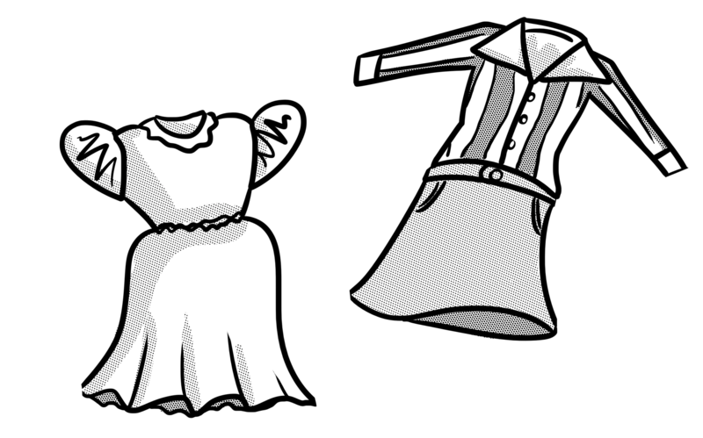
Meaning: has means owns or possesses.
Example: She has new clothes.
Your example: ________________________________________________
Trick: h as

Now practise:

Word 4: was

Meaning: was means lived or existed before now.
Example: I was late.
Your example: ________________________________________________
Trick: as it was

Now practise:

Word 5: busy

Meaning: busy means active or has lots to do.
Example: My mum is always busy.
Your example: ________________________________________________
Trick: busy on the bus

Now practise:

