Common Exception Words

Family 4: do, to, today, no, go, so

Commissioned by The PiXL Club Ltd.
October 2018
This resource is strictly for the use of member schools for as long as they remain members of The PiXL Club. It may not be copied, sold nor transferred to a third party or used by the school after membership ceases. Until such time it may be freely used within the member school.
All opinions and contributions are those of the authors. The contents of this resource are not connected with nor endorsed by any other company, organisation or institution.
PiXL Club Ltd endeavour to trace and contact copyright owners. If there are any inadvertent omissions or errors in the acknowledgements or usage, this is unintended and PiXL will remedy these on written notification.

© Copyright The PiXL Club Limited, 2018
Common Exception Words – Family 4

Word 1: do

Meaning: do means to perform or complete something.
Example: I like to do good things.
Your example: ________________________________________________
Trick: d o

Now practise:

Word 2: to
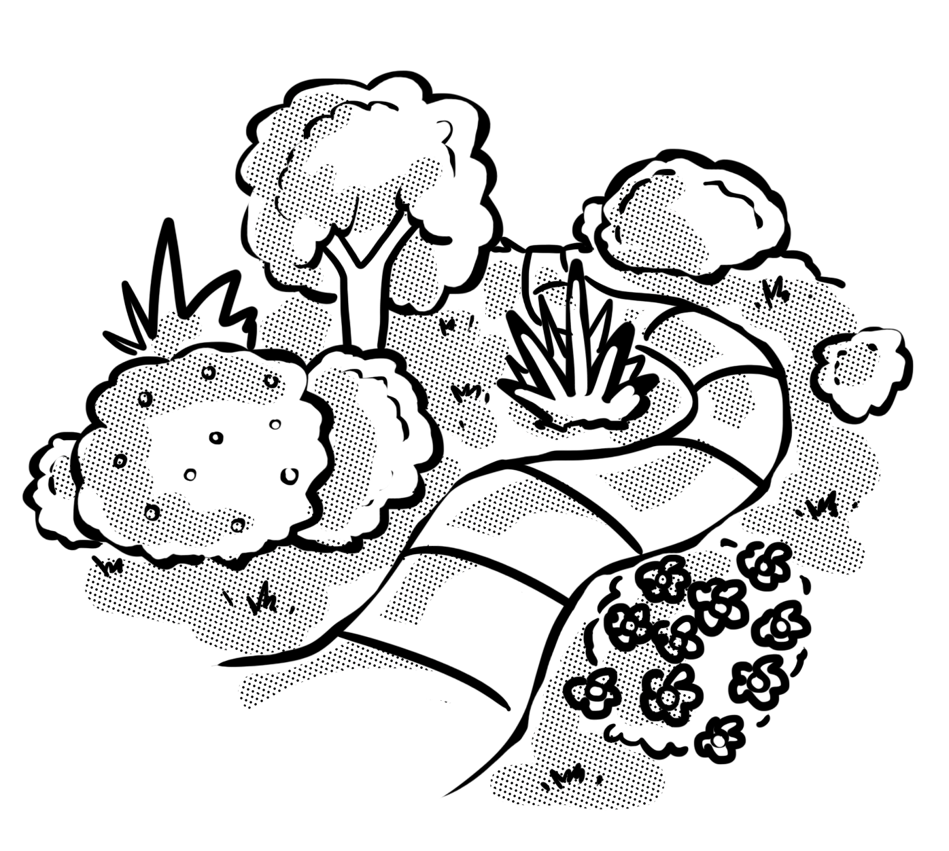
Meaning: to suggests a destination. It can also be used as part of a verb.
Example: I like to go to the park.
Your example: ________________________________________________
Trick: t o

Now practise:

Word 3: today
Meaning: today means this day.
Example: Let’s go to the park today.
Your example: ________________________________________________
Trick: to day

Now practise:

Word 4: no
Meaning: no is negative. It also means not any.
Example: No! I have no money left.
Your example: ________________________________________________
Trick: o no!

Now practise:

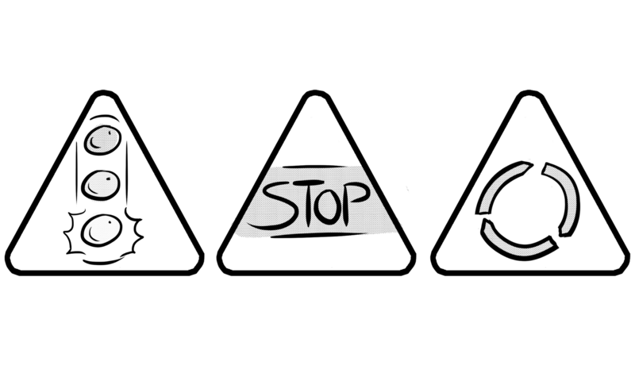
Word 5: go
Meaning: go means to leave, move or travel.
Example: We have to go now.
Your example: ________________________________________________
Trick: o, can we go?

Now practise:

Word 6: so
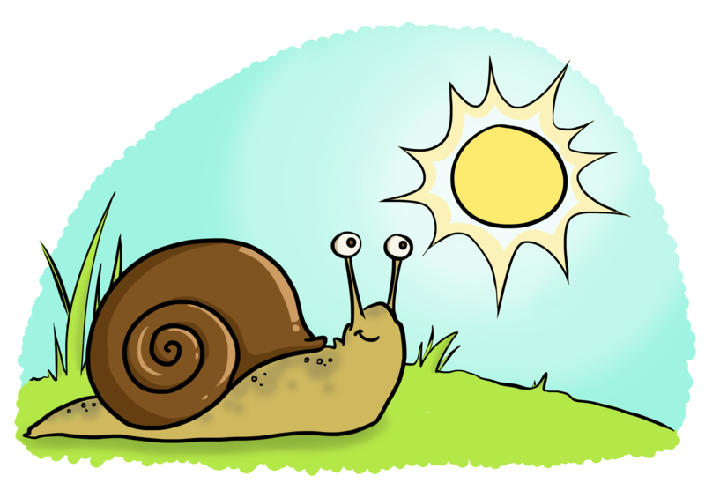
Meaning: so is used to stress, compare or connect ideas.
Example: He is so slow.
Your example: ________________________________________________
Trick: o so clever

Now practise:

